3

**5th Grade Connection**

April 22-25, 2025

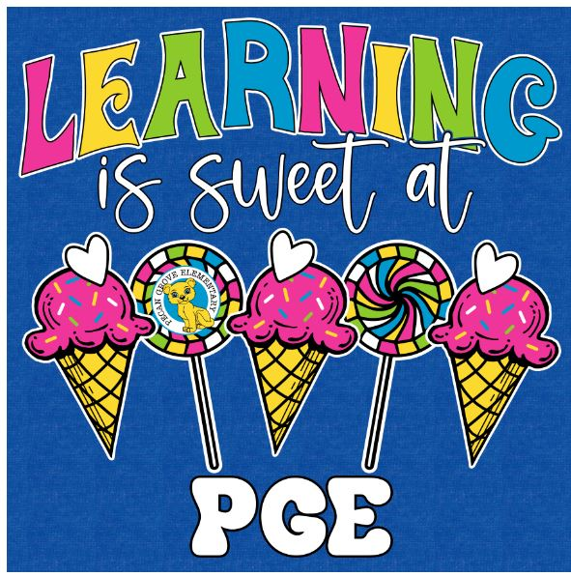

* **ELA—** Research and Novel Study
* **Math:** STAAR Review
* **Social Studies—**Appomattox and The Gettysburg Address
* **Science:** STAAR Test

**Upcoming Events/Grades**

* STAAR Review
* STAAR Science April 23rd
* STAAR Math April 30th

Please send a nutritious snack that is easy to eat to school with your student. All snacks must be peanut free. Examples of this include Cheez-Its, Pretzels, or baby carrots.

Reminders:

**What we are learning:**